

Software design document

Pharmacy JoHealth



# Revision History

|  |  |  |  |
| --- | --- | --- | --- |
| **Version** | **Name** | **Reason For Changes** | **Date** |
| *1.0* | *Hasan Alhwietat* | *Initial Revision* | *4/11/2023* |
| 2.0 | *Hasan Alhwietat* | *Design* | *4/24/2023* |
| 3.0 | *Hasan Alhwietat* | *Construction* | *5/25/2023* |
| 4.0 | *Hasan Alhwietat* | *Testing* | *6/10/2023* |
| 5.0 | *Hasan Alhwietat* | *Implementation and support* | *6/15/2023* |

# Approved By

Approvals should be obtained for project manager, and all developers working on the project.

|  |  |  |  |
| --- | --- | --- | --- |
| **Name** | **Signature** | **Department** | **Date** |
|  |  | BP-IT-Development |  |
|  |  |  |  |

Contents

Revision History 2

Approved By 2

1. Introduction 5

1.1 Overview 5

1.2 Purpose 5

1.3 Project Scope 6

1.4 List of Abbreviation 6

2. Overall Description 6

2.1 Problem Statement 6

2.2 Proposed Solution 6

2.2.1 Project Idea 6

2.2.2 Stakeholders 7

2.2.3 Actors 7

2.3 Areas of Risk 8

2.4 Product Overview 8

2.4.1 Functional requirement 8

2.4.2 Nonfunctional Requirement (Quality Attributes) 9

2.4.2.1 Reliability 9

2.4.2.2 Availability 9

2.4.2.3 Security 9

2.4.2.4 Maintainability 10

2.4.2.5 Portability 10

2.4.2.6 Usability 10

2.4.2.7 Performance 10

2.5 System Analysis 10

2.5.1 Class Diagram 10

2.5.2 Use case Diagrams (Per functionality) 11

3. Overall Design 12

3.1 High-Level Design (HLD) 12

3.1.1 Sitemap 12

3.1.2 Wireframes 14

3.1.3 Mockups 19

3.2 Low Level Design (LLD) 24

3.2.1 ERD: - 24

4. Overall Development 25

4.1 Development Overview 25

4.2 The preferable Development Technique, Tool, and Software Development Methodology 25

4.3 Solution Evaluation 25

4.3.1 Development Techniques Comparison 25

4.3.2 Development Tools Comparison 25

4.3.3 Software Development Methodology Comparison 26

4.4 Development Plan Discussion 26

4.4.1 Peer review feed back 26

4.4.2 Interpret the peer review feedback 26

4.5 Application Development 26

4.5.1 Database 26

4.5.2 Screenshots of your application 26

5. Testing 27

5.1 Testing plan 27

5.2 Performance review 27

5.3 Critical review for all application development phases 27

5.4 Application evaluation and future development 28

6. Implementation and support 28

Table of Tables

Table 1 Advantages and Disadvantages of types of each design tool 10

Table 2 Advantages and Disadvantages of types of each development tool 11

Table 3 Test cases plan table 13

Table of Figures

[Figure 1 A use case to supply chain members relations 9](https://hatuniversity-my.sharepoint.com/personal/lina_hammad_htu_edu_jo/Documents/Courses/HTU%20courses/Application%20Development/2022%20Spring/Slides/SDD%20-%20my%20vesrion%20.docx#_Toc104153686)

[Figure 2 a use case to enterprise architect user guide 9](https://hatuniversity-my.sharepoint.com/personal/lina_hammad_htu_edu_jo/Documents/Courses/HTU%20courses/Application%20Development/2022%20Spring/Slides/SDD%20-%20my%20vesrion%20.docx#_Toc104153687)

# Introduction

## Overview

This document presents a proposal to solve the problem of customers who have problems finding the medicines they need in pharmacies. The proposed solution is an application that allows customers to order the medicines they need online and receive notifications when their orders are ready for collection or delivery.

It also includes a description of how the app works, the stakeholders and actors in the project, and an overview of functional and non-functional aspects including customers, pharmacies, and development staff primarily involved in the work of the app.

## Purpose

The purpose of the software design document is to provide a comprehensive and detailed technical specification for the development team to implement the proposed solution. It serves as a roadmap that defines the architecture, components, interfaces, and design patterns of the application. It provides guidance on how to implement, test, and maintain. It is a reference for stakeholders to understand how the application works, what features it provides, and ensures a high user experience. to all stakeholders.

The target audience is primarily the development team who will be responsible for implementing the application effectively and is intended for the project manager, quality assurance staff and other people who need to understand the technical details of the application.

## Project Scope

The scope of the project will include developing an application for ordering medicines via the Internet instead of visiting pharmacies in search of the medicines that he needs. It will also include testing and publishing the application to ensure that it meets the functional and non-functional requirements specified in the program specification and requirements document. The project team will be responsible for designing the application, implementing it, testing it accurately, and providing documentation for the project to maintain and develop the application.

## List of Abbreviation

AWS: (Amazon Web Services) is a cloud computing platform offered by Amazon. It offers a wide range of services including computing, storage, databases, analytics, networking, machine learning, security, and more

SDD: Software Design Document.

RAD: Rapid Application Development.

UML: Unified Modeling Language.

ERD: Entity Relationship Diagram.

# Overall Description

## Problem Statement

Usually, people who take medicines go to pharmacies in order to take the medicines they need, and they often have difficulty obtaining some of the medicines they need, and they have to go to many neighboring pharmacies to search for these medicines, and sometimes they cannot find these medicines, and this matter It makes the patient despair of this recurring problem. And he is forced not to take this medicine that he needs for a certain period until it is available or he buys an alternative to this medicine that may not suit him.

## Proposed Solution

## Project Idea

A mobile application in which the patient fills in the prescriptions or chooses the medicines he wants through the description and adds them to the shopping cart, and the patient then chooses either to deliver or visit the pharmacy to take the medicines he requested in order to save time and effort on the customer and improve the user experience, and the application sends a notification to the nearest A pharmacy from the patient has these medicines, and in the event that the medicines that were ordered are ready for receipt, a notification will be sent to the user that the request is ready.

## Stakeholders

Stakeholders: Individuals or groups of people who affect or are affected by the project are referred to as stakeholders. Thus, in our project, we have various types of stakeholders, such as:

1. Customers: (Patients) are the people who will order medicines from pharmacies, and the application will help provide their needs, and it must be easy to use in order to obtain the service.
2. Pharmacies: Pharmacies will be part of the stakeholders in the project because they will be responsible for the direct database between them and the application in order to distribute orders to pharmacies in order to know the stock they have and that they are able to accommodate a number of orders.
3. The pharmacy staff: They are the most important people in the interest because they will receive requests from patients and prepare patients’ requests their opinion is important for the project, and the project must do what they need to facilitate the process for them.
4. Governments: (Project licenses, drug licenses) The Ministry of Health will influence the project through its approval and rules.
5. Employees: The employees of the company have important decisions as the project manager, full stack developers, UI & UX designer, and quality assurance, anyone decision of them will affect the project.
6. Investors: They help support the application financially in order to reap profits, such as Hakeem and JPM

## Actors

A role played by a user or any other system that interacts with the project is specified by an actor. It could represent human users, external hardware, or other subjects. Actors are always external to the system and interact with it directly by initiating a use case, providing input to it, and/or receiving outputs from it.

1. Users: Customers (Patient) They are the main users of the application to order and receive medicines from pharmacies by photographing the prescription or adding medicines to the shopping cart and choosing either to deliver or pick up.

The pharmacy employee will also interact with the application by accepting orders, preparing medicines for the customer, and sending a notification to the customer that the order is ready. In the case of delivery, the pharmacist will send a notification to the customer and the delivery person.

As for the company's employees, they will make a link between the customer, the pharmacy, and the delivery employee.

As for the method of payment, it will be through the application, Visa or Cash, when receiving the order from the pharmacy, or receiving the order from the delivery employee.

1. Database systems and serves: A database from the pharmacy + the Ministry of Health database + the application database. The application will communicate with the pharmacy that contains the medicines in order to add requests to the application. As for the Ministry of Health database, the medicine information and additional details will be determined through it.
2. Cloud platforms: AWS the application database will be responsible for security and ensuring that data is not lost.

## Areas of Risk

|  |  |  |
| --- | --- | --- |
| Risk description | Stage | Priority |
| 1. Disable communication between the company and the AWS in which all software information is stored. | Implementation | Medium |
| 1. When the quantity of orders becomes high in a particular pharmacy, which exceeds the absorptive capacity, it may lead to the loss of some orders as a result of pressures on the application. (Capacity) | Development | Medium |
| 1. The occurrence of attacks on sensitive data due to the expiration of the partnership contract with the company’s protection systems, or the reduction of some features that the attacker may exploit and change drug information or make a loophole in payment processes. | Security | Low |
| 1. Problems may occur with some devices due to incompatibility with operating systems. | Testing | Medium |
| 1. The functionality of the application depends on a stable connection to the Internet. If the client's connection is not stable, it will lead to not getting the features like notifications, etc. | Implementation | Low |

## Product Overview

## Functional requirement

1. Login: The application must allow users to log into their accounts using their username and password to access the features and services of the application.
2. Create an account: The application allows the creation of accounts for pharmacies, customers and drivers based on the users’ choice, and each of them has his own information, the pharmacy (name, number, email, address), customers (name, number, email)
3. Forgetting the password: The password can be changed via the number or email for verification
4. The customer will request the medicines through the application, either by photographing the prescription or adding the medicines to the shopping cart, and then the request will be sent to the pharmacies near the customer, and then one of these pharmacies that have the medicines will accept the request and send a notification to the customer in the event that the medicines are ready To receive, but in the case of delivery, a notification will be sent to the customer and the driver in case of readiness, and the driver will contact the customer to determine his location
5. Payment methods: The payment method will be either from the pharmacy, Visa or Cash, or through the Visa application, or upon receipt of the order from the driver, Cash
6. Evaluation: The customer, the pharmacy, and the driver can evaluate the services they receive from the application
7. The application will contain medicines, it can see some information such as indications for use, side effects, methods of use, etc. (Drug catalogue)
8. The customer, the pharmacy and the driver can, in the event of any problem, communicate with the company via the phone number or the conversation in the application or via e-mail

## Nonfunctional Requirement (Quality Attributes)

## Reliability

The application must be reliable because it is responsible for people's lives, which means that all the data inside the application is of great responsibility, and it must perform all functions accurately, and users must be able to trust the application, which is that it works without errors and is able to deal with a large number of users without no stop.

## Availability

The application must provide users with services to rely on for their drug needs, and the application must be available around the daily working hour, and inform users in advance in the event of malfunctions or maintenance, and avoid doing this during peak hours.

## Security

The application must be secure because it deals with sensitive data such as medicines and payment information. Strong encryption protocols must be used to protect user data and implement strong authentication mechanisms to prevent unauthorized access. Periodic monitoring must be done to ensure the security of the application and prevent possible electronic attacks.

## Maintainability

An important requirement to ensure the continuity of the work of the application, it must be easy to maintain and the possibility of updating and development with a structure that allows the modification of components easily and the development plan must be followed to avoid the occurrence of current or future errors.

## Portability

The application must be portable, which means that it must be able to work in different platforms and devices smoothly and work on both iOS and Android systems, and it must be compatible with screen sizes and resolutions and be able to work with different network conditions.

## Usability

The application must be easy to use and clearly navigate between user interfaces in order to facilitate ordering prescriptions for customers.

## Performance

The application must have high performance, fast response times and low latency in order to provide a smooth and efficient experience for all users

## System Analysis

## Class Diagram

The diagram shows the categories and their relationships to the features and operations of the application.

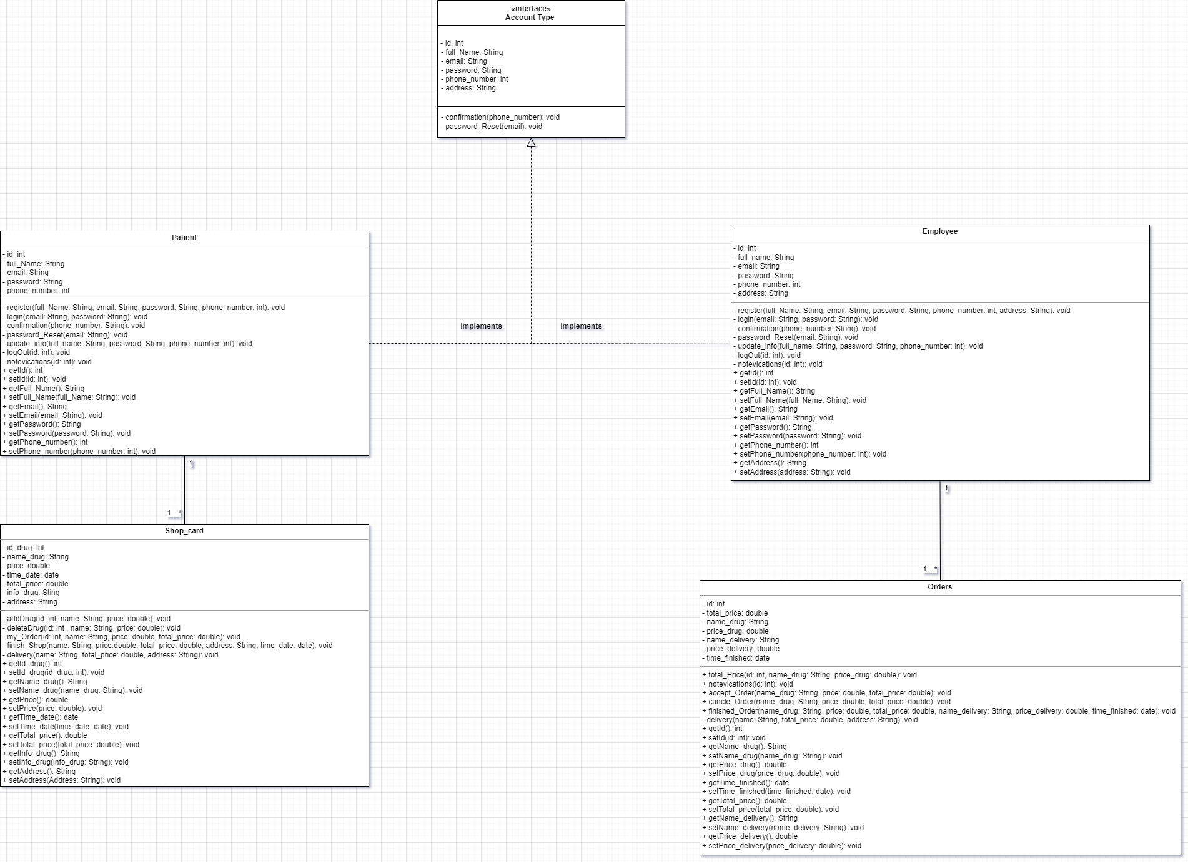

Figure 1 Class diagram for system

## Use case Diagrams (Per functionality)

1. Use case (user) He can log in, add/delete a medicine to the cart, view the drug information, log out, modify personal data, enter the settings to change the language, delete the account, etc., select payment methods, view the current order or view old orders, check some information such as email and phone number, and evaluate the employee, view notifications, determine the receipt or delivery of the request, and communicate with support via messages or frequently asked questions.
2. use case (Employee) You can log in, log out, view the status of the request, accept it or reject it, see if the customer wants to receive or deliver the request, check the email, number, job ID, enter the settings to change the language, delete the account, etc., select the site, evaluate the customer, view notifications, and view current requests That you provide and previous requests that have been completed and communicate with support via messages or common questions.

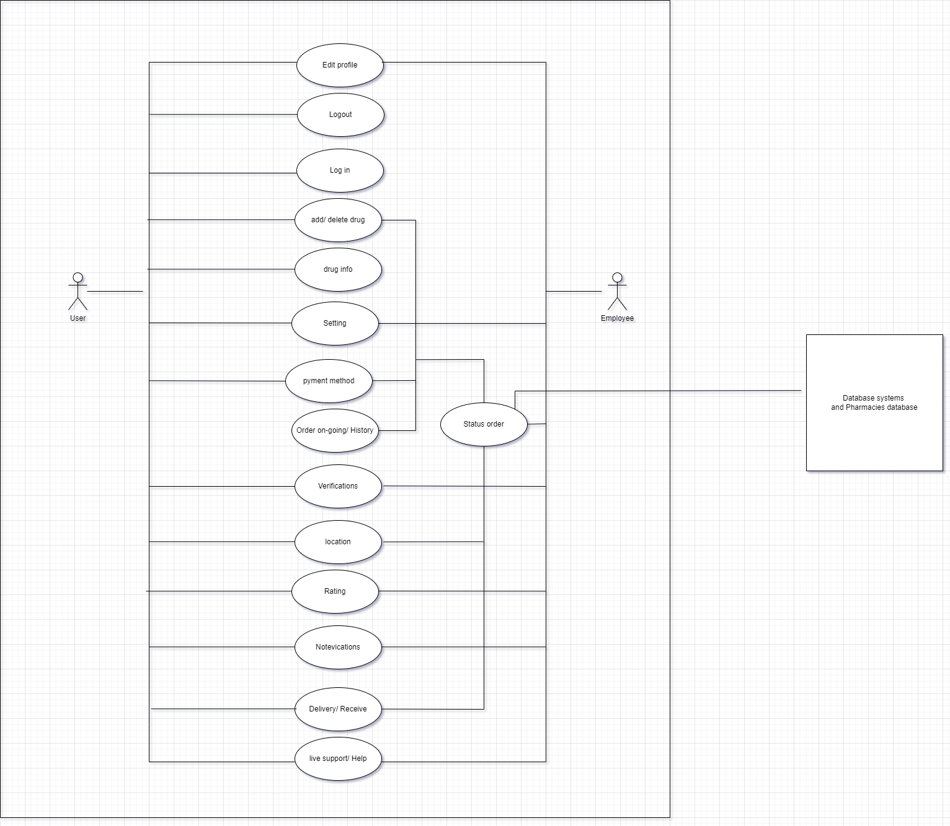

Figure 2 A use case for user and employee

# Overall Design

## High-Level Design (HLD)

## Sitemap

1. Patient: First, when the patient opens the application, he will choose the type of account, patient, and then he will log in or create an account. In case he forgets the password, he can request a new password, and then on the main page, he can navigate to many pages, including the camera, which he can photograph and send the medical prescription or By entering the type of medicine he needs, then browsing, adding the medicine, obtaining additional information, and completing the shopping, and you can select the receipt or delivery of the order, and you can follow the order on the current orders page or view old orders, and you can go to the notifications and profile page, modify the data, watch the reviews, and check the Data From the main menu on the home page, you can contact support via messages or the most frequently asked questions, access the settings, modify the password or address, view the laws and licenses, and specify payment methods.

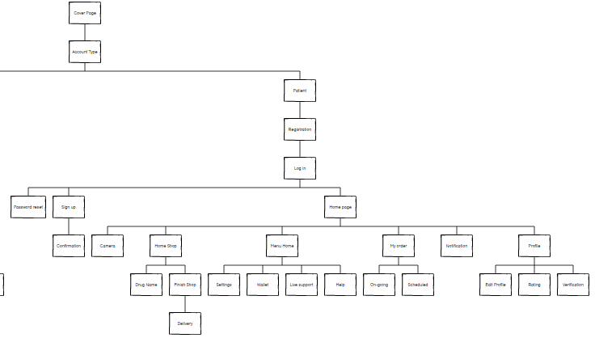

Figure 3 A site map for patient

1. Employee: First, when the pharmacy employee opens the application, he will choose the account type, employee, and then he will log in or create an account. In case he forgets the password, he can request a new password, and then on the main page, he can accept and reject requests, view some information, and can navigate to many pages, including Requests to see the requests that he is currently making or pre-orders, and he can also complete the request that he is making in the event of completion, and you can go to the notifications page and the profile, modify the data, view the ratings, and check the data, and from the main menu on the home page, you can contact support via messages or the most frequently asked questions And entering the settings and modifying the password or address or viewing the laws and licenses.

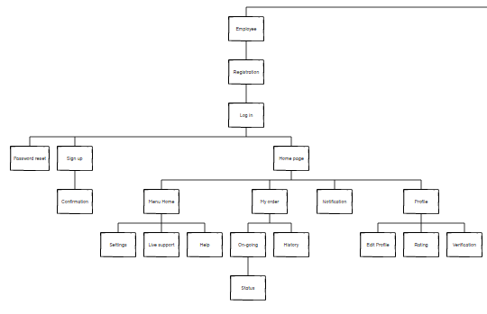

Figure 4 A site map for Employee

## Wireframes

1. Patient: -

The first page is the cover that contains the logo and the name, and then press start to move to the second page through which the type of account is selected, which contains a picture, a sentence, and two options, either a patient or an employee. If the patient is selected, the login page will appear for him by email and password, or create an account using the full name, email, password and phone number, and he can recover the password in case of forgetting via personal email.

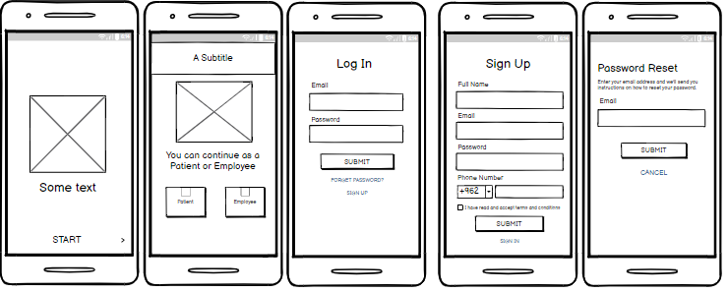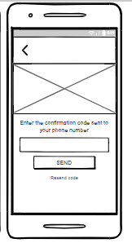

Figure 5 A wireframes for patient

After completing the registration process, you will go to the patient’s home page, through which he can go to many pages, including the main menu in which the settings are located, specifying payment methods, contacting support or the most frequently asked questions, and logging out. It is also possible through the home page to go to orders You can also go to the notifications from which you receive important messages, and you can go to the personal profile through which you can modify personal data, view rating, and verify the validity of the data

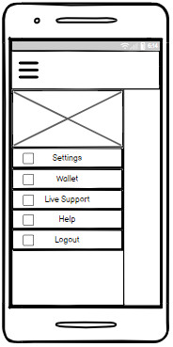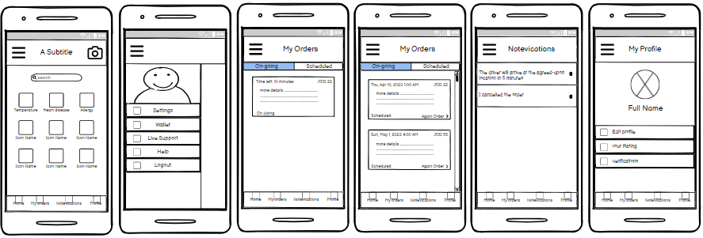

Figure 6 A wireframes for patient

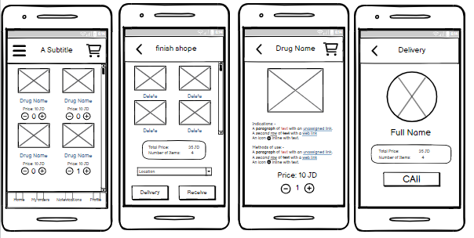Through the main page, you can select the type of medicine that you need, which will help you choose the medicine without losing. After that, the medicine that you need will be added to the cart, and then when you click on the image or the name of the medicine, details of the medicine will appear, and when you click on the cart, the items that will appear for you chose it and the prices of each item and the total. In case you want to delete some medicines, then you will specify the location and specify receipt or delivery. In the event of delivery, the driver’s picture, name, total price and contact will appear to you.

Figure 7 A wireframes for patient

When you go to the personal file and go to modify the data, your personal picture will appear, which you can modify and modify the email, name and phone number. When you go to the rating, you can see your evaluation on the program. When you go to verification, you can verify your email and number that you are the main owner.

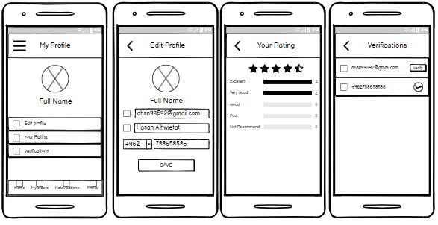

Figure 8 A wireframes for patient

When you go to the main menu and when you go to the settings through which you can change the password or the language or view the rules or permanently delete the account from the database and you can go to the wallet through which you can specify the method of payment and you can go to support and talk to it through messages or Go to the help where you can see some of the most frequently asked questions that will help you in using the application

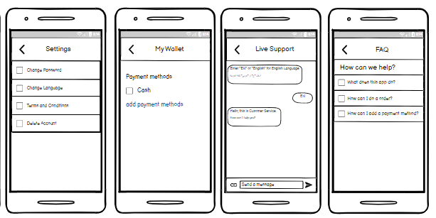

Figure 9 A wireframes for patient

1. Employee: -

When going to the account type selection page, and in the event that the employee chooses, the login page will appear with the e-mail and password, or create an account using the full name, e-mail, password, address and phone number, and then confirm the registration, and he can recover the password in case he forgot it via e-mail profile.

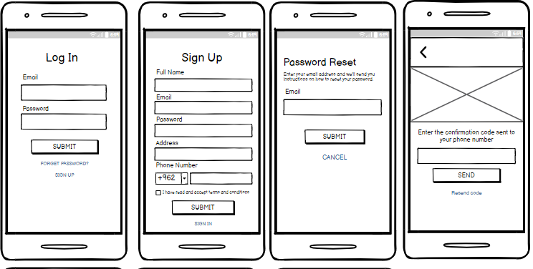

Figure 10 A wireframes for employee

After completing the registration, you will move to the employee's home page, through which he can start receiving requests, view requests, and approve or reject, and he can go to many pages such as the main menu, through which he can enter the settings, communicate with support and help, log out, and he can go to notifications to view messages The task and go to the personal file to see some information and go to the current requests that the employee is making and see some information and move to the status of the request in the event that the request is completed, in which he will see some information about the patient and the driver in the event of delivery and the total amount and he can also see the previous requests that were made finish them.

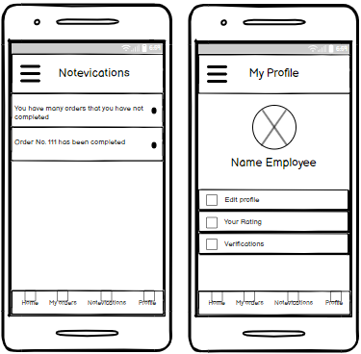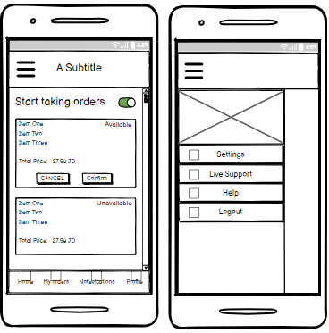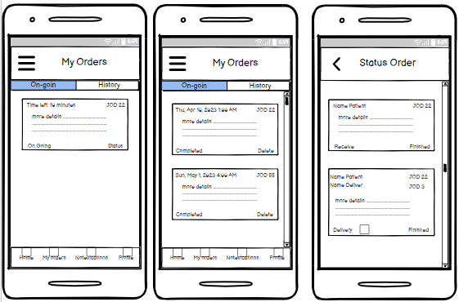

Figure 11 A wireframes for employee

When you go to the main menu and when you go to the settings through which you can change the password or change the language or change the location or view the rules or permanently delete the account from the database and you can go to the support and talk to it through messages or go to the help where you can see some the most frequently asked questions that will help you in using the app

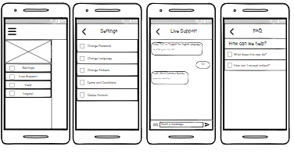

Figure 12 A wireframes for employee

When you go to the profile and go to edit data, your personal photo will appear, which you can edit and edit your email, name, address and phone number. And by going to the ratings, you can see your rating on the program. And go to verification, you can verify your email, number and medical ID that you are the main owner.

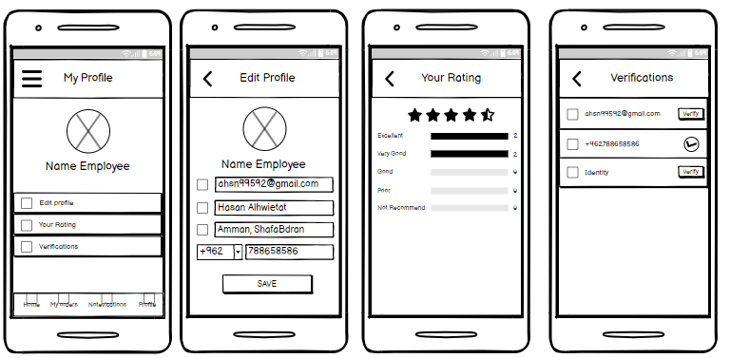

Figure 13 A wireframes for employee

## Mockups

1. Patient: -

The first page contains the logo, the name, and a start button, and the second page contains a title, an image, a sentence, and two choices, either an employee or a picture, to specify the type of account and the third page contains the login form, the fourth page contains the recovery of the password via e-mail, the fifth page contains the account creation form through the full name, email, password, number, and a send button, and the sixth page is to confirm the creation of the account containing a picture, a sentence, and a button to send or resend.

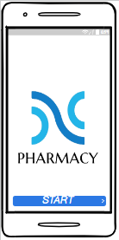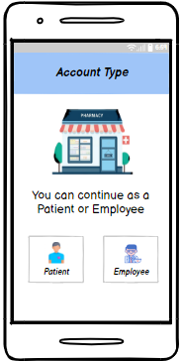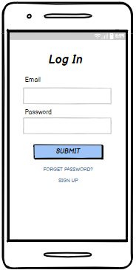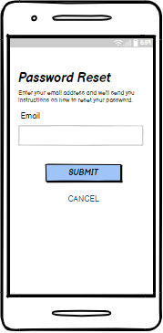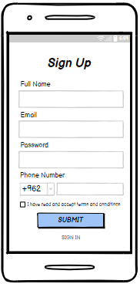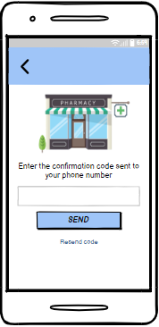

Figure 14 A mockups for patient

The first screen is the patient's home page and contains the main menu, camera, search, categories, and the bottom bar. The second screen is the main menu and contains settings, payment, contact support, assistance, and exit registration. The third screen, which is the current requests, contains the main menu, navigation between current and previous requests, and displays information about the request. And the bottom bar, either the fourth screen is the previous orders and it contains the main menu and navigation between the current and previous orders and information about previous orders and the bottom bar for navigation. The fifth screen is the notifications and it contains the main menu and the bottom bar for navigation and the messages you receive. The sixth screen is the profile and it contains the main menu and captions, profile picture, name, and options such as file modification, rating, and verification.

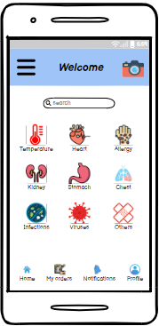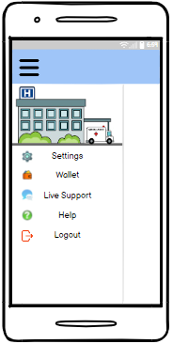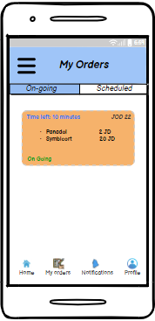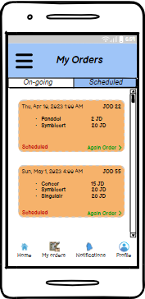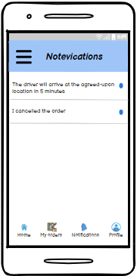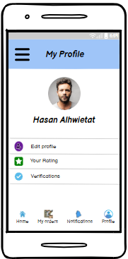

Figure 15 A mockups for patient

The first screen is for modifying the profile and contains a return to the profile page and the personal picture, modifying the name, email, number, and the save button. The second screen is the rating and contains a return to the profile and your evaluation. The third screen is verification and contains a return to the profile and verification options such as the email and the number, or the fourth screen, it is the settings and it contains a return to the main menu and many options such as changing the password, the language, the rules, and deleting the account. The fifth screen is the wallet and it contains the return to the main menu, specifying payment methods, and adding another method. The sixth screen, contacting support, contains the return to the main menu and messages and send a new message

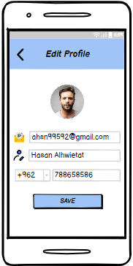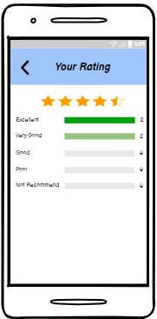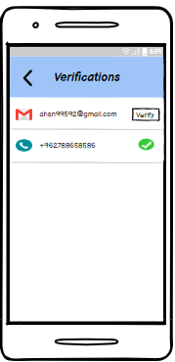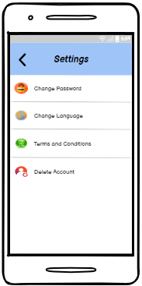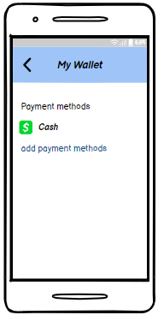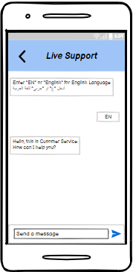

Figure 16 A mockups for patient

The first screen is the help and contains the most frequently asked questions and the return to the main menu. The second screen is the categories that have been selected and contains pictures of the drugs, their names and prices, adding to the cart or deleting them, and it contains the main menu, the bottom bar and the cart. The third screen is the completion of shopping and contains the medicines. Which was chosen, the total price, the location, and determining whether to receive or deliver. The fourth screen contains the name of the drug, the return to the home page for shopping, information about the drug, adding and deleting it, the price, and the cart. The fifth screen is delivery, and it contains interesting information, a picture, and a contact.

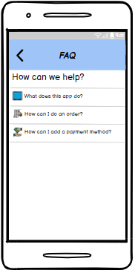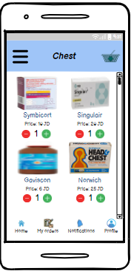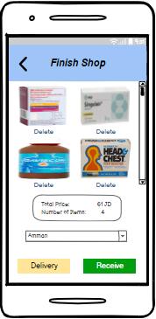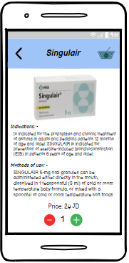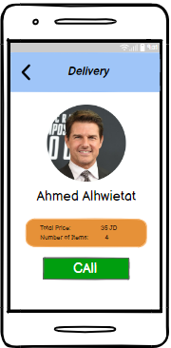

Figure 17 A mockups for patient

1. Employee: -

The first screen is the login page for the employees and it contains the email, the password, a send button and a link to create an account and recover the password. The second screen contains the steps to recover the password by entering the email and sending or pressing Cancel in case you do not want. The third screen is the creation of the account and it contains Enter the full name, email, password, address, number, send button, and a link to go to the login. The fourth screen is the confirmation of creating an account and contains the return button. On the third screen, an image, a sentence, a place to enter the confirmation code, the send button, and the link to resend the code again. The fifth screen is the main page contains a title, a main menu, a button to activate receiving requests, schedules that contain the details of the request, a button to accept or reject the request, and a bottom bar for moving. The sixth screen is the main menu and contains a button for back, a picture, entering the settings, contacting support and assistance, and logging out. The seventh screen is Settings and contains a button to return to the main menu and enter to change the password, language and address, view the rules and delete the account

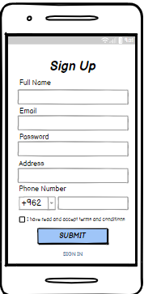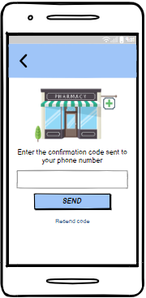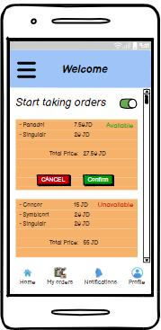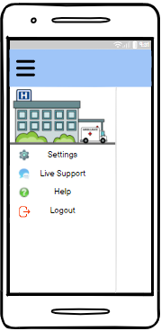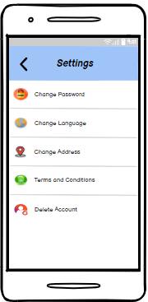

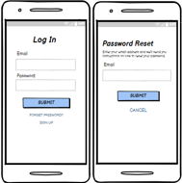

Figure 18 A mockups for Employee

The first screen contains contacting support via messages and returning to the main menu. The second screen is help and contains a button to return to the main menu and the most frequently asked questions. The third screen is notifications and contains alerts that you receive, the main menu and the bottom bar for navigation. The fourth screen is the profile and contains On the main menu, a picture, the full name, options for modifying the file, classification, verification, and a bottom bar. The fifth screen is the modification of the file and contains a return to the file, a picture, and places to modify the email, name, number, and a save button. The seventh verification contains a number of email, number and identity verifications.

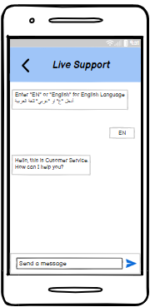

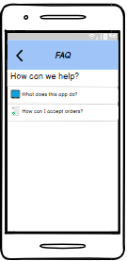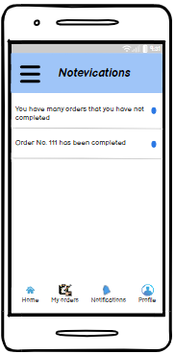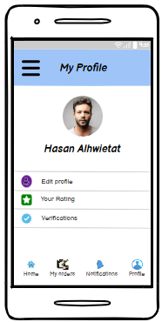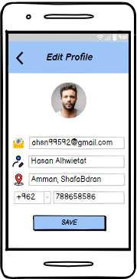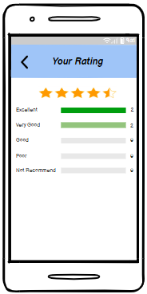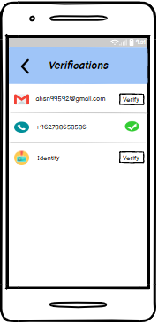

Figure 19 A mockups for Employee

The first screen is the current orders and contains a main menu, an upper and lower navigation bar, and a table containing information for the current order that he is making and a link in case he wants to end the current order. The second screen is the previous orders and contains a main menu, an upper and lower navigation bar, and a table that contains information for previous orders that have been It has been completed. As for the third screen, it is the status of the request, and it contains a reference to the current requests, and a table containing information for the request, the patient, the driver, and the completion of the request.

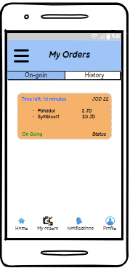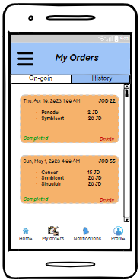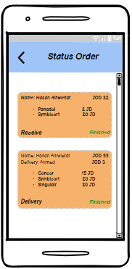

Figure 20 A mockups for Employee

## Low Level Design (LLD)

## ERD: -

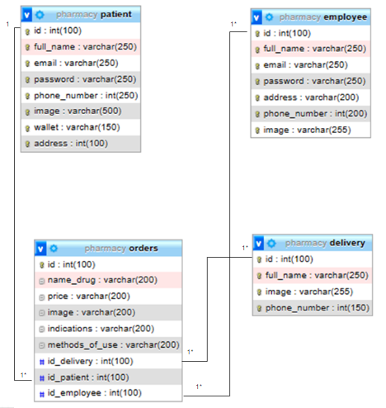The database will store the orders(ID, Name_drug, Price, Image, Indications, Methods_of_use, Id_delivery, Id_patient, Id_employee) table, the patient(ID, Full_name, Email, Password, Phone_number, Image, Wallet, Address, Id_orders, Id_delivery) table, the delivery(ID, Full_name, Image, Phone_number) table, and the employee(ID, Full_name, Email, Password, Address, Phone_number, Image, Id_orders) table.

Figure 21 ERD

# Overall Development

## Development Overview

RAD: (Rapid Application Development) It is a software development environment that allows the creation of fast and effective applications that provide tools and frameworks in order to simplify and accelerate the development process and provide software solutions that include RAD platforms, drag and drop functions, the ability to create simple code, and the possibility of merging functions. Its advantages include accelerating the development life cycle, reducing time and effort, and enhancing cooperation between developers and owners the interest includes types of web applications, mobile devices and desktop. The RAD types are low code, no code, and code generators platform.

Creating an application by writing the code from scratch completely requires the creation of all functions and components manually in order for the application to work and is characterized by your flexibility and customization and allows developers to control functions and design, but it takes a long time from using the RAD system and requires experience in programming languages and principles of software development without relying on tools made pre-built.

Customization of a current product to making modifications to requirements based on the new product allows companies or users to make modifications to the current solution such as colors, design, or functions, or to make new additions according to their needs, through which you can save a lot of time and effort if you have a product similar to what you want Create it and this is difficult to find a suitable design for your needs without making modifications to your functions and not achieving the required of the new product.

## The preferable Development Technique, Tool, and Software Development Methodology

The technique that was used in this project is the rapid development of the application without code, which aims to speed up the development process by not having to write coding, which is used to create prototypes and take feedback from the user to present an application appropriately and within scope. This technology helps users to create applications from Through the visual interface through drag-and-drop and ready-made components, people who are not familiar with writing coding are allowed to use this method.

The tool that was used to develop the application is Adalo, which is considered a tool without code that allows the creation of mobile applications and websites without the need for special knowledge of the code. It provides a drag-and-drop interface and pre-prepared components. In addition, it supports systems such as Android and ISO. There is also the possibility of creating a database and additional functions, as well as integration. With external processes in order to simplify the application creation process

As for the methodology, we used the agile methodology, which is an iterative and collaborative approach to developing applications that helps to provide high quality in a short time through continuous planning, improvement and flexibility in dealing with changes, and emphasizes cooperation between developers with stakeholders during the development process and helps to organize work and set priorities and adapting to changes.

## Solution Evaluation

The solution to the problem in choosing a software development methodology is to take into account the specific requirements, needs and constraints of the project. Based on the solution that includes the use of the Adalo tool and the RAD No Code technique and the methodology that was chosen agile, each tool has its positives and negatives. The main reason for using the Adalo tool is that you do not need Writing coding provides a drag-and-drop interface and ready-made elements that help simplify the application development process without spending more time and effort, which enables anyone to use it without the need for a specific technology. The technique chosen, RAD No Code, combines rapid development in addition to not having to write the code, which helps in faster development and cooperation between developers and stakeholders, is better than other technologies that may not adapt to changes such as waterfall and is less flexible. Interconnected with the project, rapid development and promotion of flexibility and effective project management.

## Development Techniques Comparison

Compare the differences between the various development techniques.

Table : Development technique Comparison

|  |  |  |  |  |  |
| --- | --- | --- | --- | --- | --- |
| # | Technique name | | Advantages | Disadvantages | When to use |
| 1 | From Scratch |  | 1- Development from scratch that allows full control of all aspects of the application  2- Flexibility in choosing the appropriate technologies and programming languages for the best application based on needs  3- The ability to expand when building the application from scratch, a solid foundation, and improving performance to make it better in the future  4- Personal ownership of the application so that there are no third-party license restrictions or frameworks | 1- The great time and effort that will be taken to implement the project completely from scratch  2- High skills and practical experience that developers must have to build the application  3- It requires a high cost to create the application compared to using other frameworks and systems | Technique is used when you want to build the application from the ground up that requires writing all the code, when the requirements are unique and cannot be met by existing frameworks and systems, when you want complete control over the application, when you need a high degree of flexibility and customization, and when there is a long-term strategy |
| 2 | RAD | No Code | 1- Rapid application creation and deployment using pre-made visual interfaces  2- A little time and effort to develop the application  3- Higher productivity in the application development process and reduces the use of professional developers  4- High flexibility due to ready molds  5- The possibility of seamless integration with external systems and software interfaces | 1- Constraints When a specific work is required, it is very complicated to work on  2- Building simple applications that are not appropriate when building large applications that require more features  3- Limit customization and control options  4- Raising the application leads to paying continuous fees due to the lack of ownership  5- Limited scalability and not suitable for long-term strategies | This technique is used when you want to create a prototype quickly and when the user cannot write the codes, it does not require high skills and technical experience in the field of creating applications and the complexity is medium to easy in using this technique |
| Low Code | 1- Combine visual development tools and pre-built components with a little bit of coding to quickly build and deploy an app  2- Reducing effort by using drag and drop functionality with simple coding writing  3- Cooperation between developers and stakeholders in the development process in order to enhance feedback and improvement on the application  4- Expandability and maintainability with the growth of the application, you can adjust to the needs | 1- Low customization options and control restrictions  2- You cannot easily transfer these built systems to other technologies because they will be negatively affected in the long term  3- It affects the learning curve for those who wish to use it, because they should know the features of the system, its tools, and development methodologies | This technique is used when you want to develop an application quickly with little customization and take advantage of the previously described components. This depends on the specific requirements of the project and is used when iterative and agile development in order to facilitate systems and obtain rapid prototypes with minor modifications. |
| Code Generation | 1- Increase productivity because it reduces the amount of manual coding  2- Ensures consistency and adherence to predefined patterns and templates, and this reduces errors in application  3- Prototype code generation is easy to iterate by generating automatic code with high specifications  4- Maintainability so that you can make the required changes and the code can be re-created  5- Little effort, little risk, and little time  6- The ability to reuse the code with other templates | 1- It requires an understanding of the modeling language of the system in order to know the use of tools and the creation of codes  2- Limited customization of molds so that it is difficult to express some requirements  3- Difficulty finding errors and fixing them compared to the code written manually | This technique is used when you need to create prototypes with rapid development while automatically generating code that provides high-level specifications and when you want to standardize consistency with the database and reduce errors while generating code for common functions in order to save time |
| 3 | Customization |  | 1- Tailored to specific system needs and according to requirements  2- An improved user experience by creating a customized, unique and easy-to-use user interface  3- Improving productivity, streamlining workflow, and gaining user satisfaction  4- Improving programs to match the company's specific operations  5- The possibility of competition by providing unique features, ready solutions and meeting market needs | 1- An increase in development time and effort because it requires creating custom features and implementing them requires additional cost  2- Customized programs need intensive and continuous maintenance and updates  3- Integration with other systems is difficult when customization complications occur | This technology is suitable when you want to build a complex and specific program that is not done by ready-made solutions, when the requirements are unique to the company, to do maintenance and make adjustments to some unique features, and when you want an application that focuses on improving the user experience through ease of use and effectiveness |



## Development Tools Comparison

Compare the differences between the various development tools.

Table : Development tools comparison

|  |  |  |  |  |  |  |
| --- | --- | --- | --- | --- | --- | --- |
| # | Name | Type | Advantages | Disadvantages | Cost | Features |
| 1 | Bubble | No Code | 1. It does not require technical expertise and knowledge of the code within the reach of anyone 2. Creating the application easily and with a simple interface 3. Allows the use of ready-made templates and building complex applications easily 4. Responsive, scalable design that handles huge amounts of data | 1. No code can be written 2. Limited functionality 3. Not useful for application developers 4. Some benefits are not available, which leads to restriction 5. The cost is high in the event of requesting advanced features, and the cost increases in the event of increased use | Medium | 1- An easy-to-use interface that allows drag and drop functionality  2- The ability to create applications without code  3- Create a database, define data types, and create relationships between objects  4- Responsive design and compatible with all devices  5- Provides the option of publishing and hosting  6- Expandability with external programming interfaces |
| 2 | OutSystems | Low Code | 1. 1-Create applications with little or no coding 2. 2-Rapid development and reduction of time to market 3. 3-Integration from external systems 4. 4-Expandability and is suitable for large companies   5-Full stack development, UI and backend design | 1. Not suitable for developers because it reduces the learning curve 2. Limited customization due to the small coding 3. Licensing costs are high for small businesses 4. A proprietary platform which makes the inability to move to other tools 5. Limited flexibility not suitable for specialized applications | High | 1- A visual development environment that allows building applications through drag and drop without the need for extensive coding  2- The rapid development of applications because it provides pre-created templates and patterns that can be easily reused and modified  3- Provides full stack development and includes the front end and back end of the application  4- High and strong integration capabilities with external systems and services  5- Prioritizing security and governance in application development  6- The ability to expand and accommodate more users without any burden |
| 3 | CodeSmith Generator | Code Generation | 1. Developers can create ramps quickly and easily, saving time and effort 2. Access to data and web services 3. It is easy to build complex code 4. Automated code generation 5. Multiple language support 6. Code reset | 1. Developers need time and effort to learn the tool 2. Limited applicability especially requiring complexity and data structures 3. Relying heavily on templates 4. It is a commercial tool, which means that the cost is high | High | 1- Create template-based code to generate code and allow developers to define the structure and content of the code being generated  2- The templates are customizable and designed according to their needs in various programming languages  3- Create a simple database using SQL  4- Scalability of coding creation and integration with external tools and frameworks such as Visual Studio which provides an easy experience and file management  5- Scalability and the possibility of improving performance |
| 4 | AppSheet | No code | 1. Supports a range of databases and cloud services, google drive, dropbox 2. Supports many operating systems 3. It allows teams to work together 4. Easy to use and powerful to create applications without previous skills 5. Multi-platform support | 1. Limited functionality because it does not contain features like development platforms 2. Not suitable for complex applications 3. Limited customization 4. Data security is rather weak 5. The price is very high. | Medium | 1- It allows integration with different data sources and cloud services  2- Develop applications without code  3- Data modelling and relationships between different tables  4- Collaboration among team members by providing comments and tests  5- It provides jobs without an internet connection  6- Security and control by setting permissions to restrict access to data and implementing encryption |
| 5 | Adalo | No code | 1. You do not need to have experience in coding 2. It provides pre-made templates, which facilitate the creation of prototypes easily 3. Compatibility with Android and IOS platforms, in addition to the web 4. Seamless integration with databases 5. A wide range of ready-made components such as buttons, menus, maps, etc. | 1. The customization is limited compared to the large-scale custom coding. 2. The advanced functions are complex allowing building simple to medium applications 3. It does not perform better than applications based on full custom coding 4. Switching to another system requires rebuilding parts of the application | Medium | 1- A visual development environment through drag and drop  2- Create an easy and fast application without writing code  3- pre-built interfaces and components such as buttons, maps, and more  4- Integration with databases such as Airtable  5- Users are allowed to create conditional procedures and specify the required actions  6. Provides features such as user authentication and authorization  7- Allows external custom actions using JavaScript and other destinations  8- Publishing and distribution on ISO, Android systems |

## Software Development Methodology Comparison

Compare the differences between the various software development methodologies.

|  |  |  |  |
| --- | --- | --- | --- |
| Compare | Definitions | Advantages | Disadvantages |
| Waterfall | It is a method of linear and sequential software development that is done by tracking a set of stages in a fixed order so that if a stage is completed you cannot return to it. Also, this method assumes that the requirements of the project are clear by the client and the project manager and a unified vision about the final result. | 1- It provides a clear and structured approach to program development that is easy to manage  2- Comprehensive documentation during the development process for maintenance  3- Each stage has specific outputs that can be easily evaluated  4- Focuses heavily on pre-defined requirements and reduces the possibility of misunderstanding owners  interest  5- A very accurate and good method for unified vision  6- Good for training junior developers | 1- The limited flexibility that this method adopts, so that it is not possible to modify any stage after its completion, which leads to a greater cost of time when a change in requirements occurs.  2- The slightest cooperation between stakeholders and developers during the development process, which leads to difficulty in correcting some requirements  3- It is not possible to discover any defects or errors in the system until after the completion of the course, and this increases the cost  4- The possibility of non-compliance with the requirements of the stakeholders due to the small participation, which increases the occurrence of defects in the final product  5- It is not suitable for large projects that need to update the stages continuously because it takes a lot of time and in order to adapt to future changes. |
| RAD | It is a rapid application development methodology. It is an iterative and incremental approach that focuses on rapid prototyping, iterations, and sharing activities with stakeholders. It aims to accelerate the development process through early user feedback and changes. | 1- Faster time to market the application through rapid product delivery and enabling rapid response to stakeholder needs  2- High cooperation between stakeholders and developers in order to meet the correct final expectations  3- Flexibility and ability to adapt to changes to meet requirements  4- Obtaining a high rate of user satisfaction through the involvement of stakeholders in the early stages in order to meet the expectations of users  5- With each iteration completed, the product becomes more accurate | 1- The possibility of project scope creeping due to repetition and making changes, which leads to expanding the project scope  2- Relying mainly on the participation of stakeholders and end users throughout the development process, which affects the effectiveness of the method  3- The possibility of obtaining limited documentation due to the high speed of this method, which makes it difficult to understand the system in the future  4- This method requires a skilled and highly experienced team because it affects the success and efficiency of the method  5- Possibility of delay in product delivery and it is possible to increase the cost due to changes |
| Agile | It is an iterative and incremental approach to software development for continuous improvement, early delivery, and collaborative work between development teams and stakeholders. It is very similar to RAD, but is more appropriate for large projects. | 1- Flexibility and ability to adapt to changing requirements throughout the development process  2- Collaborate closely with development teams, stakeholders and users throughout the development cycle  3- Early and continuous delivery in order for stakeholders to see progress  4- Transparency and visibility within development teams with stakeholders  5- Increasing efficiency and product quality over time due to repetition | 1- There is no ambiguity in the project so that the scope of the project is not clear from the outset  2- Instability in requirements can disrupt the development cycle, which leads to increased costs and long time  3- Requires a time commitment that may not be appropriate for some projects  4- Requires high experience and skill of the team that can influence the progress of the successful development cycle  5- It may lead to not documenting all iterations, which leads to a lack of comprehensive documents for future reference |
| Scrum | It is an agile framework and methodology for software development that focuses on iterative development and continuous improvement for solving complex adaptive problems and is keen on flexibility, organization and delivery of small iterations called sprints. | 1- Flexibility and adaptability throughout the development process helps in obtaining new insights and taking feedback from clients  2- Transparency and cooperation between team members and stakeholders  3- Daily meetings and quick planning in order to enhance mutual understanding  4- Early and regular delivery by presenting work programs every race finish  5- Encourages self-organization and collaboration between multiple teams. This helps to increase productivity  6- Customers can change their mind and it can be processed easily  7- Higher software quality and reduction of risks | 1- Complete requirements are required to start the development process, which leads to misunderstanding or delay in the development process  2- It requires a cooperative and skilled team in order to organize and make decisions  3- The inability to set a fixed date makes it difficult to provide accurate estimates for the project  4- Possibility of creeping project scope if you cannot manage changes to requirements and specifications effectively  5- Depends on the availability of stakeholders on a regular basis can hinder the progress and effectiveness of the approach |
| DevOps | It is a software development methodology that combines software development with IT operations and shares together the development cycle from design to development process to enhance collaboration and integration between development teams and operations teams. | 1- Increase collaboration and consistency between development, operations and communication teams by working together throughout the development cycle  2- It allows programs to be released frequently and reliably in order to reduce errors  3- Get to the market as soon as possible  4- Automation of development and processes leads to a shorter and faster development cycle for features and updates  5- Improving quality by conducting continuous tests, which enables more reliable programs to be issued with fewer errors  6- Increase productivity by streamlining workflows and eliminating manual processes | 1- It requires high training and skills to implement and benefit from this methodology  2- It relies heavily on complex infrastructure settings, automation tools, and cloud infrastructure that can affect systematic implementation  3- It requires joint cooperation for continuous improvement  4- It is difficult for security measures to be fast-paced |

## Development Plan Discussion

## Peer review feed back

There are many notes that have been obtained. I will first mention the notes on the application for the project. First, after completing the purchase of the medicines, I need to make a list in which to confirm the medicines that you want and do the deletion and add a medicine. Secondly, modify the bouton of receiving the application and put the word pickup instead of receive, and thirdly the cover page It does not contain the company name.

As for the notes on the project, first, the problem statement is unclear and incomprehensible. Second, the project idea has not been specified if it is a mobile application or something else. Third, the use case must clarify between what is inside the system and outside. Fourth, write more about the risks. Fifth, do not write more about the risks. Fifth, the ERD does not show the relationship. between the attribute

## Interpret the peer review feedback

The first note that you modified is the stockholders. You made a separation between the pharmacies and the pharmacy employee, where the pharmacies will be part of the stakeholders because they will be responsible for the direct database between them and the application in order to know the stock of medicines that they have in order to know the requests that can be retrieved. As for the pharmacy employees, they are part It is in the interest because they will receive requests from patients and process orders, so the application will facilitate the process for them. Secondly, that was about the class diagram, which is creating a class interface and placing on it variables and functions common to class employee and class patient. Thirdly, placing the home menu on the main pages such as the home page and my profile. page and notification page and my order page Fourthly, choose the appropriate colors for the application based on the main logo of the application Fifthly, a feature has been developed in the application in the event that the user logs in through the patients and he is a pharmacy employee by mistake or vice versa, he will enter the correct place based on the type of account of the one who created it.

## Application Development

## Database

We use the database to store application data such as searching, adding and deleting customer information, etc. This is done through four procedures on the database: create, update, select, and delete. These operations help ease the use of the application appropriately for the project and the ability to use the application easily. The JoHealth application was built with Adalo. Which uses the PostgreSQL database.

PostgreSQL: It is an open-source database management system that is characterized by scalability and offers a wide range of capabilities through its support for various complex data types, and it is keen on data integrity, follows the relational model, and allows storing structured data in tables with previously defined schemas, which leads to distinguished performance and contains a wide range of libraries and the tools that support its integration.

## Screenshots of your application

Link Application: <https://previewer.adalo.com/545f784e-b270-400d-b496-08cb23f4f1df>

Patient: Email: [20120098@htu.edu.jo](mailto:20120098@htu.edu.jo) password: 0000

Employee: Email: [hasan@gmail.com](mailto:hasan@gmail.com) password: 0000

Link video YouTube: <https://youtu.be/nLhERIzvfhA>

# Testing

## Testing plan

1. **Test ID** **and/or name:** 1
2. **Module name:** Make a new order
3. **Test data**: name category, id drug, name drug, price drug, total price, number of items
4. **Assumptions or preconditions**: He must have an account, after a successful login, after the main page appears, through which he chooses the appropriate category for him, and a page of drugs will appear for him through which he creates the order
5. **Test priority:** High.
6. **Test scenarios:** Log in, it will automatically go to the home page, then choose the category of the drug you want, then add the drug to the shopping cart, then go to the shopping cart and select the drug you want to buy, then select the damage to receive or deliver the order, and the order will be put into action on my order page
7. **Test ID** **and/or name:** 2
8. **Module name:** start taking in order
9. **Test data**: id drug, name drug, price drug, total price
10. **Assumptions or preconditions**: He must have an account, after a successful login, after enabling the start taking orders
11. **Test priority:** High
12. **Test scenarios:** Log in, then you will automatically go to the home page that contains the activation of receiving orders. Upon activation, a table will appear containing the order information, and then choose to accept or reject
13. **Test ID** **and/or name:**3
14. **Module name:** Drug picture UI
15. **Test data**: id drug, name drug, price drug, picture drug, name category
16. **Assumptions or preconditions**: He must have an account, after a successful login, after the main page appears, through which he chooses the appropriate category, after a page of drugs will appear
17. **Test priority:** Medium
18. **Test scenarios:** Log in, it will automatically go to the home page, then choose the category of the drug you want, many drugs will appear and click on the image of the drug to see additional information in detail
19. **Test ID** **and/or name:** 4
20. **Module name:** Checking the database if a drug has been added to the database or not.
21. **Test data**: id drug, name drug, price drug, picture drug, name category
22. **Assumptions or preconditions**: He must have an account, after a successful login, after add the drug
23. **Test priority:** Medium
24. **Test scenarios:** Log in, it will automatically go to the home page, then choose the category of the drug you want, many drugs will appear and added drug and admin to check if you added in the database
25. **Test ID** **and/or name:** 5
26. **Module name:** Check if only the person with an account can access their account (Security)
27. **Test data**: id, Full_name, address, email, password, Phone_number
28. **Assumptions or preconditions**: He must have an account, after a successful login
29. **Test priority:** Medium
30. **Test scenarios:** The user will log in using the email and password, and then the admin to check if the user is the account holder by email verify
31. **Fill the below table:**

Table : Test cases plan table

|  |  |  |  |  |  |
| --- | --- | --- | --- | --- | --- |
| Test id | Steps of Happy path | Steps of Alternative path | Steps of Exceptional path | Expected result | Actual result |
| 1 | After a successful login, it will automatically go to the home page, then choose the category of the drug you want, then add the drug to the shopping cart, then go to the shopping cart and select the drug you want to buy, then select the choice to receive or deliver the order, and the order will be put into action on my order page. | After choose the category of the drug you want, then click on the drug. Details of the drug will appear. Add to the drug, and then click on the shopping cart and complete the order. | After choosing the category of the drug you want, and then many drugs appear, you can do the search, choose the drug, add it, and then complete the order | You can see the order that you have requested through the My Order page | A notification will come to him that the order has been completed successfully, and a notification will appear if the order is ready to be received (pass) |
| 2 | After a successful login, then you will automatically go to the home page that contains the activation of receiving orders. Upon activation, a table will appear containing the order information, and then choose to accept or reject | Create a new account successfully, then you will automatically go to the home page that contains the activation of receiving orders. Upon activation | After going to the home page that contains the activation of receiving orders. Upon activation does not any orders | You can see the order you have approved on the My order page | He will receive a notification that the order has been successfully accepted (pass) |
| 3 | After a successful login, it will automatically go to the home page, then choose the category of the drug you want, many drugs will appear and click on the image of the drug to see additional information in detail | After choosing the category of the drug you want, then searching for the drug and clicking on it, then additional information will appear and clicking on the image | After choosing the category of the drug you want, then click on the drug picture to see the drug information page, then the picture will not be the correct picture for the drug you want and you will get wrong information | You can click on the drug and see the details of the drug and see the image drug correctly | The user will see all the information and pictures of each drug correctly (pass) |
| 4 | After a successful login, it will automatically go to the home page, then choose the category of the drug you want, many drugs will appear and add a drug and admin to check if you added to the database correctly | After adding the drug, the admin can check by making sure that the user has received a notification of the drug they want and that the drug has been removed from the pharmacy database | After adding the drug, the admin check the database and found that the drug that was stored was not the correct drug that the user added | The selected drug will be added to the user and stored in the database correctly | Pass |
| 5 | The user will log in using the email and password, and then the admin to check if the user is the account holder by email verify | The user will log in using the email and password, and then add a way to recover the account by verifying the phone number | If the user forgets the email and password, he will not be able to access his account | The user will log in to his account correctly and to the home page | Pass |

## Performance review

The application solves the problem that patients face, which is the difficulty of finding the drugs they need easily, and they have to go to many pharmacies in search of drugs. Now the problem has been solved through the JoHealth mobile application. You can choose the drug that you want to buy, and the application will send you to the pharmacy that has this drug and you can choose a delivery in order to save time and effort in searching for the drug, the application helps to display the details of the drug, such as pictures, name, price, reason for use, and methods of use. Evaluating the performance of the application requires obtaining user satisfaction, obtaining feedback, identifying areas that require improvement, ensuring that the application provides a more efficient and appropriate experience, measuring the time needed by the patient to find the drug, etc. All operations and solutions have been implemented in the application successfully to ensure effectiveness. Design and development based on the specified functions and suitable for the user and it is easy to use, but it needs more development and adding functions so that the application becomes high quality and solves most of the weaknesses

## Critical review for all application development phases

**Analysis:** In the analysis process, we analyzed the main problem that patients face, and we developed solutions to it. Among the solutions is the mobile application that we created. Based on the problem, the requirements and functions were analyzed. Since the problem that we want to solve needs to know the number of drugs available in each pharmacy, therefore it needs a linked database. With the application database directly in order to distribute requests, we also encountered problems in identifying stakeholders, we took notes about them, and we made the required modification, and we needed to increase the number of risks expected to occur, and we wrote more.

**Design:** At this stage, we converted the proposed solutions that were presented into visual graphs and the possibility of application, and we defined the application map and pages, and we visualized the application, and we got feedback, and we added some suggested modifications for improvement in terms of colors, sizes, components, and functions, and we used the Balsamic website for the application map and wireframes, and we Using the drow.io for the user case and class diagram and ERD where there were some notes and we modified them and corrected the errors.

**Development:** At this stage, we took the design that was created and started the development process, and we used RAD technology to create the application and the Agile methodology, which is considered one of the rapid processes and the ability to change efficiently and effectively and continuous improvement. It is difficult to use and it takes a lot of time. For this, we used another tool, Adalo, which made it easy for us to create the application through the pre-prepared components, the easy visual interface, the use of the drag and drop feature, linking pages easily, and the possibility of creating a database easily without the need for code. Through the tool itself, a database was created. Data based on the ERD that we defined in the design.

**Testing:** After the application was completely created, we conducted tests for all functions and ensured that they functioned correctly and effectively and ensured the effectiveness of the user interface by testing visual objects and ensuring the interconnection of pages and checking the database such as adding medicines, deleting medicines, adding an application, modifying data, etc. It was confirmed from all of its work, we made sure of performance, protection, and speed, and a heaviness was detected in the application. When the program is run by more than 5 people, the speed becomes slow, and this needs to improve the speed, so it was confirmed that the application works properly.

**Risk:**

1. A failure occurred in the connection between our company and AWS, which is used to store all the data related to the application. Fortunately, we have backup copies of the data on a daily basis, which enables us to preserve the data from loss.
2. We faced a problem at the beginning in using the OutSystems tool, but we realized that the tool needed to spend time and effort, and we needed to speed up the development process, and we used the Adalo tool, which was easy and fast in creating applications.
3. We have avoided the occurrence of a problem between patient and employee users from a conflict in the database, and we have separated them so that if the patient makes a mistake and logs in at the employee’s place, he will enter the patients’ home page.
4. We had errors in the ERD as a result of the work of the relations between attributes, and we rectified the matter and solved the problem after taking notes, and we did it perfectly.
5. We made sure that the database takes correct data from drug names, prices, images, calculate the total price, create a request, and that the request is saved on the My Requests page, and the request is seen by the user easily and correctly.
6. One of the risks that we have not dealt with is that when the amount of requests becomes high on the application, which exceeds the capacity, some requests will be lost as a result of the high pressure on the application (capacity).
7. The occurrence of attacks on sensitive data due to the expiration of the partnership contract with the company’s protection systems, or the reduction of some features that the attacker may exploit and change drug information or make a loophole in payment processes. A solution will be found by purchasing devices with less protection than emergency services until a company is found that provides the necessary protection.

## Application evaluation and future development

**Improvement:**

1. The user can search for the drug he wants after selecting the specific category of the drug by entering the first letter or writing the full name of the drug
2. In case the user forgets the password, he can recover it by entering the e-mail and changing the password
3. The employee can see the requests sent to him and can accept or reject them
4. 36 drugs were stored in the database containing the name of the drug, category, price, indications for use, methods of use, and a photo
5. All functions in the application work normally, smoothly and easily, and the buttons have used the appropriate words for each button
6. Users can communicate with support via messages in the application, and they will be contacted
7. The user can see the current and old orders that have been completed in the order history
8. The application can be used by different types of Android and iOS systems

**Further development:**

Some features can be added in the future that will improve the application's work perfectly by dealing with an external database that is not from the Adalo tool, which will allow us to provide more features and infinite storage if we have a larger budget and more time, and it is possible to provide some servers from companies that provide Faster service, high absorptive capacity, available for all operating systems, and it is possible not to use a tool to make the program. It is possible to build the application from scratch in order to improve and control its features. The application may be more flexible and better with improvements.

# Implementation and support

Implementation plan Users will be notified in the event of maintenance work by sending a notification before the maintenance process begins, and a publication can be downloaded on the page with the date of the update or maintenance. Notifications and other It is possible to disseminate the application through advertisements on the streets, social media, celebrities, etc. and train users to handle the features offered by the application and use the functions appropriately. It is possible to explain the mechanism of ordering drug through the application by selecting the category and then searching for a name drug and add it to the shopping cart.

For the support and maintenance plan, there will be a team responsible for complaints in order to provide assistance whether by phone, mail or chat. The team is trained on how to deal with complaints and provide this feedback to the maintenance team in order to find solutions. Continuous improvements to the application every two months, so that when the application is constantly updated, it will reduce risks to the company because problems are addressed quickly and continuously based on the needs of the markets and users. A team should be formed to monitor the movement of performance. It is important to track the movement of application performance, improve response speed, and provide analytics and graphs about the application.

When the implementation, support and maintenance plans are implemented precisely and in accordance with the required procedures, an application will be created that is available daily, improved performance, and a better user experience.